CHAPTER 1

INTRODUCTION

In the modern technological era, personal safety continues to be a critical concern due to the rise in domestic violence cases, kidnapping incidents, medical emergencies, and other safety-threatening situations where the victims are often unable to seek help openly. Traditional emergency mechanisms such as mobile calls, panic buttons, wearable devices, and alert applications, although effective in controlled environments, fail under circumstances where the user is under surveillance, physically restrained, emotional distress, or unable to interact with devices manually. As a result, there exists a growing need for an intelligent, automated, and discreet emergency alert system that operates without requiring visible user interaction.
The evolution of Artificial Intelligence (AI), Natural Language Processing (NLP), and cloud-based communication APIs has enabled the development of systems that can detect speech patterns, voice commands, and emotional cues in real time. Leveraging these advancements, the proposed system introduces a Secret-Phrase Triggered Emergency Alert and Evidence Recording System, which enables users to silently activate SOS protocols by speaking a predefined covert phrase. Upon phrase detection, the system automatically initiates emergency workflows, including SMS alerts, emergency calls, real-time location sharing, and ambient audio recording, all executed silently and without user interaction.
The system functions as an always-active personal security mechanism, suitable for vulnerable individuals such as victims of domestic violence, chronically ill patients, children, elderly individuals living alone, and individuals working in high-risk environments. Unlike conventional emergency systems, the proposed solution emphasizes covert activation, automation, rapid response, and situational intelligence, making it a practical tool in real-world threatening scenarios.

1.1 Problem Statement
Victims experiencing life-threatening or high-risk situations such as domestic abuse, forced confinement, medical collapse, assault, or kidnapping often lack the ability or opportunity to manually activate emergency support systems. The absence of a hands-free and unnoticeable emergency activation mechanism may result in delayed intervention, prolonged harm, or fatal outcomes. Current emergency alert systems do not sufficiently support covert activation or automated multi-channel alert escalation and therefore fail to assist individuals who cannot physically interact with communication devices during emergencies.

1.2 Solution for the Problem
To overcome these limitations, this project proposes an intelligent emergency response system activated through a personalized secret phrase using speech recognition technology. The system continuously listens to ambient audio and remains operational in stealth mode. Once the predefined phrase is detected, the system executes emergency actions including sending distress messages, initiating automated phone calls, transmitting live geo-coordinates, and recording evidence for legal investigation. The solution ensures silent execution, high response accuracy, and the ability to function even in network-constrained environments with offline fallback mechanisms.

1.3 Existing Techniques
Several emergency alert solutions currently exist, such as:
- Wearable Safety Devices (panic bands, smart shoes, smart jewellery)
- Emergency Mobile Applications (SOS buttons, GPS trackers, rapid dial applications)
- Hardware Alarm Systems (panic buttons, IoT-based emergency triggers)
- Voice Assistant Safety Features (Google Assistant, Siri emergency call commands)
While these solutions contribute to safety, they possess limitations such as:
- Requirement of visible manual interaction
- Lack of covert activation capabilities
- Dependence on user awareness during stress or panic
- Absence of automated evidence recording and escalation workflows
- Limited customization of activation triggers
These constraints demonstrate the need for a more sophisticated, AI-enabled solution.

1.4 Proposed Technique
The proposed technique integrates speech recognition, machine learning, communication APIs, and background processing to create a silent safety mechanism. The system runs continuously in the background, monitoring for user-defined emergency key phrases. If a match is detected, a multi-layer emergency protocol is triggered including:
- Silent SMS and WhatsApp emergency messages
- Automated voice call to predefined contacts
- Real-time location tracking using Google Maps API and fallback IP-based geolocation
- Automated evidence recording (audio logs)
- Secure SQLite database logging with timestamps
This system provides end-to-end emergency handling without requiring further user interaction.

Objective
The major objectives of the proposed system include:
- To design and implement a covert emergency alert system activated through secret speech phrases.
- To automate emergency communication using SMS, calls, and instant messaging platforms.
- To incorporate real-time location tracking for rapid assistance and rescue.
- To enable secure evidence recording for legal use and post-incident investigation.
- To ensure reliability across different environmental conditions, noise levels, and internet connectivity constraints.
- To provide a customizable and user-friendly interface for phrase configuration and contact management.

Scope of the Project
The scope of this project includes:
- Developing an operational desktop/mobile prototype using AI and voice recognition.
- Integration of APIs for SMS, automated calling, and location sharing.
- Implementation of emergency data encryption and silent execution architecture.
- Support for multiple secret phrases mapped to various emergency levels.
- Audio evidence recording and secure storage capabilities.
- Offline fallback mode for limited network environments.
Future scope includes:
- Emotion-based activation using voice stress analysis
- Wearable and IoT integration
- Multilingual speech support
- Cloud-based monitoring dashboard

1.7 Organization of the Report
This report is systematically organized to provide a complete understanding of the proposed Secret Phrase Triggered SOS Alert and Evidence Recording System, covering all stages from conceptualization to implementation, evaluation, and conclusion. Each chapter has a defined purpose and contributes to the logical progression of the project documentation. The structure of the report is as follows:
- Chapter 1: Introduction – This chapter introduces the motivation behind developing a covert emergency alert system activated through a secret phrase. It explains the background of the study, defines the research problem, outlines the proposed solution, and presents the objectives, scope, and methodology adopted for the project. This chapter also guides the reader by explaining how the report is structured.
- Chapter 2: Literature Survey – This chapter provides a detailed review of existing research work and technologies related to speech recognition–based emergency systems, personal safety applications, IoT-enabled security models, and AI-powered alert frameworks. It compares previously developed systems, identifies limitations in current solutions, and establishes the research gap that this project aims to fill.
- Chapter 3: Requirement Specification – This chapter outlines the essential technical requirements of the proposed system, including hardware, software, functional, and non-functional specifications. It defines the performance expectations, operational constraints, system features, and dependencies required for successful development and deployment.
- Chapter 4: System Design – This chapter explains the architectural design and workflow of the proposed system using software engineering models. It includes design diagrams such as the basic block diagram, deployment diagram, protocol architecture, flow chart, UML sequence diagram, activity diagram, state transition diagram, and data flow diagram to illustrate internal system operations and interactions between modules.
- Chapter 5: Testing – This chapter describes the testing methodology adopted to evaluate system behavior and correctness. It presents different types of testing performed (such as unit testing, integration testing, functional testing, and system testing), along with test scenarios, test cases, execution reports, and results.
- Chapter 6: Results – This chapter presents the experimental outcomes of the system implementation. It includes performance analysis, screenshots, user interactions, phrase recognition accuracy observations, and evaluation metrics demonstrating the effectiveness and functionality of the final system.
- Chapter 7: Conclusion – This chapter summarizes the overall accomplishments of the project. It evaluates the extent to which the objectives were achieved, highlights key contributions, and discusses the societal relevance of the system. The chapter also outlines potential enhancements and recommendations for future extensions, such as multilingual support, wearable integration, and offline processing improvements.
- References – This section provides a comprehensive list of research papers, technical documentation, websites, and academic sources referred to throughout the report, following a standard citation format.

CHAPTER 2

LITERATURE SURVEY

[1] Cheng, P. & Roedig, U., “Personal Voice Assistant Security and Privacy—A Survey,” IEEE Communications Surveys & Tutorials, 2022.
Cheng and Roedig provide an extensive analysis of voice assistant platforms such as Google Assistant, Siri, and Alexa, focusing on vulnerabilities related to speech-trigger mechanisms. The study highlights that although voice assistants are widely deployed, they lack security features such as user-specific secret phrases, covert execution, and restricted access triggers. The authors emphasize risks such as accidental activation, spoofing attacks, and privacy exposure, making current assistants unsuitable for emergency applications requiring discretion. This research is significant as it identifies the need for secure, customized voice activation models — a gap directly addressed by the proposed system.

[2] Kumari, N., Cho, M., Dixon, P., & Naik, D., “Flexible Keyword Spotting Based on Homogeneous Audio-Text Embedding,” ICASSP, 2024.
Kumari et al. propose a modern keyword spotting (KWS) architecture using a hybrid audio-text embedding model to improve accuracy in detecting speech triggers under variable pronunciation and background noise. Their system tolerates speech irregularities, stress-induced variations, and environmental distortion — conditions typical during emergency situations. The researchers demonstrate that audio-text embedding significantly reduces false rejections and enhances reliability. This work directly supports the proposed system’s approach of using fuzzy phrase matching and ML-driven speech recognition for reliable covert emergency detection.

[3] Yang, G., Gu, Y., Macha, S., Tang, Q., Liu, Y., “On-Device Constrained Self-Supervised Learning for Keyword Spotting,” ICASSP, 2024.
Yang et al. focus on edge-based speech recognition optimized for low-power and offline execution environments. Their research explores quantization-aware neural networks capable of handling real-time audio without cloud dependency. The study confirms that lightweight, efficient keyword spotting models are feasible for always-listening applications without exhausting system resources. This is relevant to the proposed system, as covert emergency monitoring requires continuous background listening with minimal processing overhead and support for offline detection.

[4] Valentini-Botinhao, C., Blanco, A. L. A., Klejch, O., & Bell, P., “Efficient Intelligibility Evaluation Using Keyword Spotting,” ICASSP, 2023.
This study evaluates the robustness of speech recognition systems under real-world noise conditions. The researchers use keyword spotting as a metric to assess speech intelligibility when audio input quality is degraded. Findings show that KWS models remain effective even when speech is whispered, obstructed, or distorted — conditions common during violent or life-threatening events. The insight supports the necessity of noise-tolerant phrase detection for emergency use cases, reinforcing the design direction of the proposed project.

[5] Reddy, M. S., Vamsi, C., & Kathambari, P., “Rescue Me: AI Emergency Response and Disaster Management System,” ICAIS, 2024.
Reddy and colleagues propose an AI-driven response model that integrates API-based messaging and notification systems for large-scale disaster response. The system automates distress communication using SMS and cloud services, ensuring rapid dissemination of critical alerts. While effective in emergency broadcasting, the system lacks personalization, covert triggering, and evidence-recording functionalities. The proposed project builds on this model by enabling individualized alerts triggered through secure speech commands.

[6] Abu Zaid, M. I. M., Abdullah, R., Ismail, S. I., & Dzulkefli, N., “IoT-Based Emergency Alert System Integrated with Telegram Bot,” ISCAIE, 2023.
Abu Zaid and colleagues develop a Telegram Bot-based alerting system integrated with IoT sensors to automatically trigger emergency messages. Although the system successfully deploys messaging automation, it depends entirely on external hardware sensors and does not support voice-based triggering. Additionally, it lacks multi-step escalation, live evidence capture, and offline fallback, which limits usability during personal assault situations. This supports the relevance of integrating voice activation and multi-channel communication in emergency applications.

[7] Weerasinghe, K., Janapati, S., Ge, X., Kim, S., Iyer, S., & Stankovic, J., “Real-Time Multimodal Cognitive Assistant for Emergency Medical Services,” PerCom, 2024.
This research introduces a multimodal assistant for medical professionals, capable of processing real-time audio, sensor input, and contextual data while managing emergency medical procedures. While designed for professional use, the study demonstrates the feasibility of combining speech recognition and automated decision logic in real-time high-risk environments — validating key principles used in the proposed project.

[8] Devika, T. V., et al., “ResQlink: Smart Kidnap Detection and Emergency Alert System,” ICAIS, 2025.
The ResQlink project proposes a wearable safety device that detects sudden movement (suggestive of forceful capture) and triggers emergency alerts. The system generates alerts and records environment sound, but its dependency on movement sensors rather than intentional user activation may lead to false alerts. The proposed project refines this strategy by enabling deliberate voice-triggered control with greater precision and stealth.

[9] Patil, S. R., Srividya, B. S., Agarwal, L., & Raj, R., “Women Safety Alert System using IoT with Fingerprint Authentication and Real-Time Alerts,” CONECCT, 2024.
This study presents an authentication-supported safety system using fingerprint scanning and IoT messaging. Although secure, physical authentication may not be feasible in abusive or emergency situations. The research underlines the importance of frictionless activation — reinforcing the value of a speech-triggered approach.
CHAPTER 3
REQUIREMENT SPECIFICATION

This chapter outlines the complete set of requirements necessary for the development, deployment, and functioning of the Secret Phrase Triggered SOS Alert and Evidence Recording System. The system is designed to autonomously listen for a predefined secret phrase and trigger emergency actions without requiring visible user interaction. To achieve this, the project relies on artificial intelligence–driven speech recognition, automated alerting frameworks, evidence logging, and background processing mechanisms. The following sections define the software, hardware, functional, and non-functional requirements that ensure the system operates efficiently, securely, and reliably under real-world emergency scenarios.

3.1 Software Requirements
The system requires specific software components to support speech processing, communication automation, and user interaction. These include:
- Operating System: Windows 10 or later / Linux-compatible environments
- Programming Language: Python version 3.9 or above
- IDE / Development Environment: PyCharm or Visual Studio Code for coding, debugging, and version control
- Libraries and Frameworks:
  - SpeechRecognition and Google Speech-to-Text API – used for speech-to-text conversion and secret phrase detection.
  - PyAudio / Pydub – for capturing and processing live audio streams for continuous monitoring and recording.
  - Twilio API / smtplib module – for automated SMS alerts and initiating emergency voice calls.
  - Requests and Geopy packages – to retrieve real-time GPS/geolocation data using Google Maps or network-based fallback.
  - SQLite3 – used as a lightweight and secure database solution to store emergency contacts, system logs, alerts, and configuration settings.
  - Tkinter or PyQt (UI Framework) – used to create a configuration dashboard where users can set emergency contacts and trigger phrases.
- Browser: (Optional) Google Chrome or Edge for testing or management dashboards if cloud extensions are implemented.
These software components collectively enable the system to listen passively, interpret speech, send alerts automatically, track location, record evidence, and store logs securely.

3.2 Hardware Requirements
Since this is a system designed to operate on standard computing platforms without specialized external sensors, its hardware requirements are minimal but crucial for stable and real-time performance. The system requires:
- Laptop/Desktop Device: A general-purpose computing system capable of running Python applications in the background.
- Processor: Minimum Intel Core i3 or equivalent (Core i5 recommended for faster speech recognition and API response handling).
- RAM: Minimum 4 GB (8 GB recommended to maintain responsiveness when running background listeners alongside other applications).
- Storage: At least 10 GB free disk space to store audio recordings, logs, and system files; SSD storage is preferred for faster data access and handling.
- Microphone: A built-in or external microphone with clear input capability is mandatory for listening and recording.
- Internet Connection: Wi-Fi or mobile hotspot is required for sending alerts, retrieving GPS data, or contacting external APIs. Offline operation may still allow phrase detection, but emergency communication requires connectivity.
Optional hardware such as external storage devices or encrypted USB drives may be used later for secure evidence export or extended deployment.

3.3 Functional Requirements
The system must fulfill several core functionalities to provide reliable emergency response automation. The key functional requirements are detailed below:
- Continuous Background Listening:
The system must continuously run in the background without requiring manual activation. It should remain silent, hidden, and lightweight while listening for the predefined emergency phrase.
- Secret Phrase Recognition and Matching:
The speech recognition module must interpret the captured audio and compare it to the stored phrase. The system should tolerate whispering, accents, minor variations, or low-volume speech, ensuring reliable detection even during distress.
- Emergency Alert Triggering:
Upon recognizing the secret phrase, the system must immediately and silently activate a chain of emergency responses without user confirmation.
- Automated SOS Messaging and Calling:
The system must send a pre-configured distress message to registered contacts along with real-time location coordinates. It should also automatically initiate a call to emergency numbers or trusted individuals to maximize rescue chances.
- Real-Time Location Tracking:
The system must acquire live location data using GPS-based services or fallback IP-based lookup when location services are disabled or unavailable.
- Audio Evidence Recording:
Once triggered, the system must begin recording ambient audio for a preconfigured duration. These recordings may later serve as digital evidence for legal or investigative purposes.
- User Configuration Panel:
The system should provide a secure and intuitive interface that allows the user to set, modify, or delete emergency contacts and update the secret phrase without needing technical expertise.
- Data Logging and Storage:
All triggered events, including timestamps, communication attempts, and recorded evidence, must be securely stored for auditing and legal review.

3.4 Non-Functional Requirements
Beyond core functionality, the system must meet several performance and operational standards to ensure real-world reliability, safety, and ethical design. These are:
- Performance:
The detection and response time must be minimal, ensuring the alert is triggered within 1–3 seconds of the secret phrase being spoken. Background monitoring should consume minimal CPU and memory resources.
- Reliability:
The system must operate continuously without requiring user intervention. It should recover from network outages by retrying communication and ensuring logs and evidence remain intact even after a system restart.
- Security:
Sensitive data, including emergency contacts, user phrase, logs, and audio recordings, must be encrypted and protected using secure access mechanisms. The system should prevent unauthorized modification or disclosure of stored information.
- Stealth and Privacy:
The system must remain hidden during normal use and emergency activation. No pop-ups, tones, or on-screen notifications should appear, ensuring the safety of the user under threat.
- Portability:
The system must be deployable on multiple platforms and adaptable to future mobile or wearable devices with minimal modification.
- Maintainability:
The code architecture must be modular, well-documented, and structured to support updates, debugging, and feature expansion without major redesign.
- Scalability:
The system should support future enhancements such as multilingual trigger recognition, cloud backup, AI-driven emotional analysis, and integration with government emergency services.
CHAPTER 4

SYSTEM DESIGN
This chapter presents the architectural and operational design details of the AI-Based Tracker and Blocker system. It illustrates how various components interact to track employee activity, analyze productivity, and execute blocking protocols through diagrams and structured design models.

Basic Block Diagram
The basic block diagram shows the overall system flow.
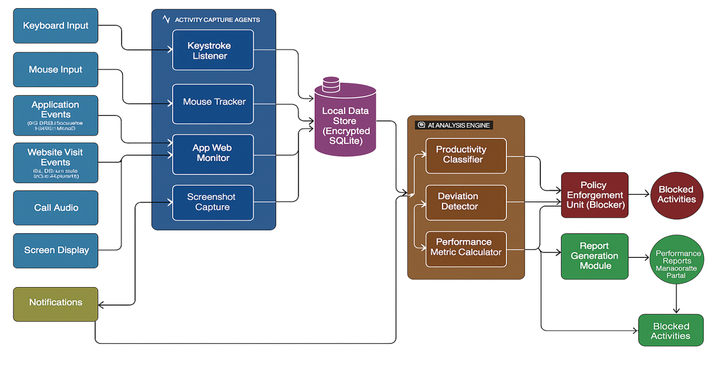

Figure 4.1: Basic Block Diagram of the AI-Based Tracker and Blocker System
Figure 4.1 illustrates the fundamental architecture of the AI-Based Tracker and Blocker System. The system begins with various inputs generated by employee activities, such as keyboard inputs, mouse movements, application launches/usage, website visits, and the content displayed on the screen. These raw inputs are captured by specialized Activity Capture Agents, which process and convert them into structured activity data. This data is then securely stored in a Local Data Store. The AI Analysis Engine continuously accesses this stored data, where it performs productivity classification, detects deviations from defined work patterns, and calculates various performance metrics. Based on the analysis, the Policy Enforcement Unit (Blocker) may be activated to restrict access to unauthorized applications or websites. Concurrently, the Report Generation Module compiles the analyzed data into comprehensive Performance Reports and Flagged Deviations, which are then presented via an Administrator Panel or sent as Notifications. This architecture ensures discreet and immediate monitoring and control through continuous digital activity capture.

Deployment Diagram
This diagram illustrates the components deployed on the user's laptop or PC.
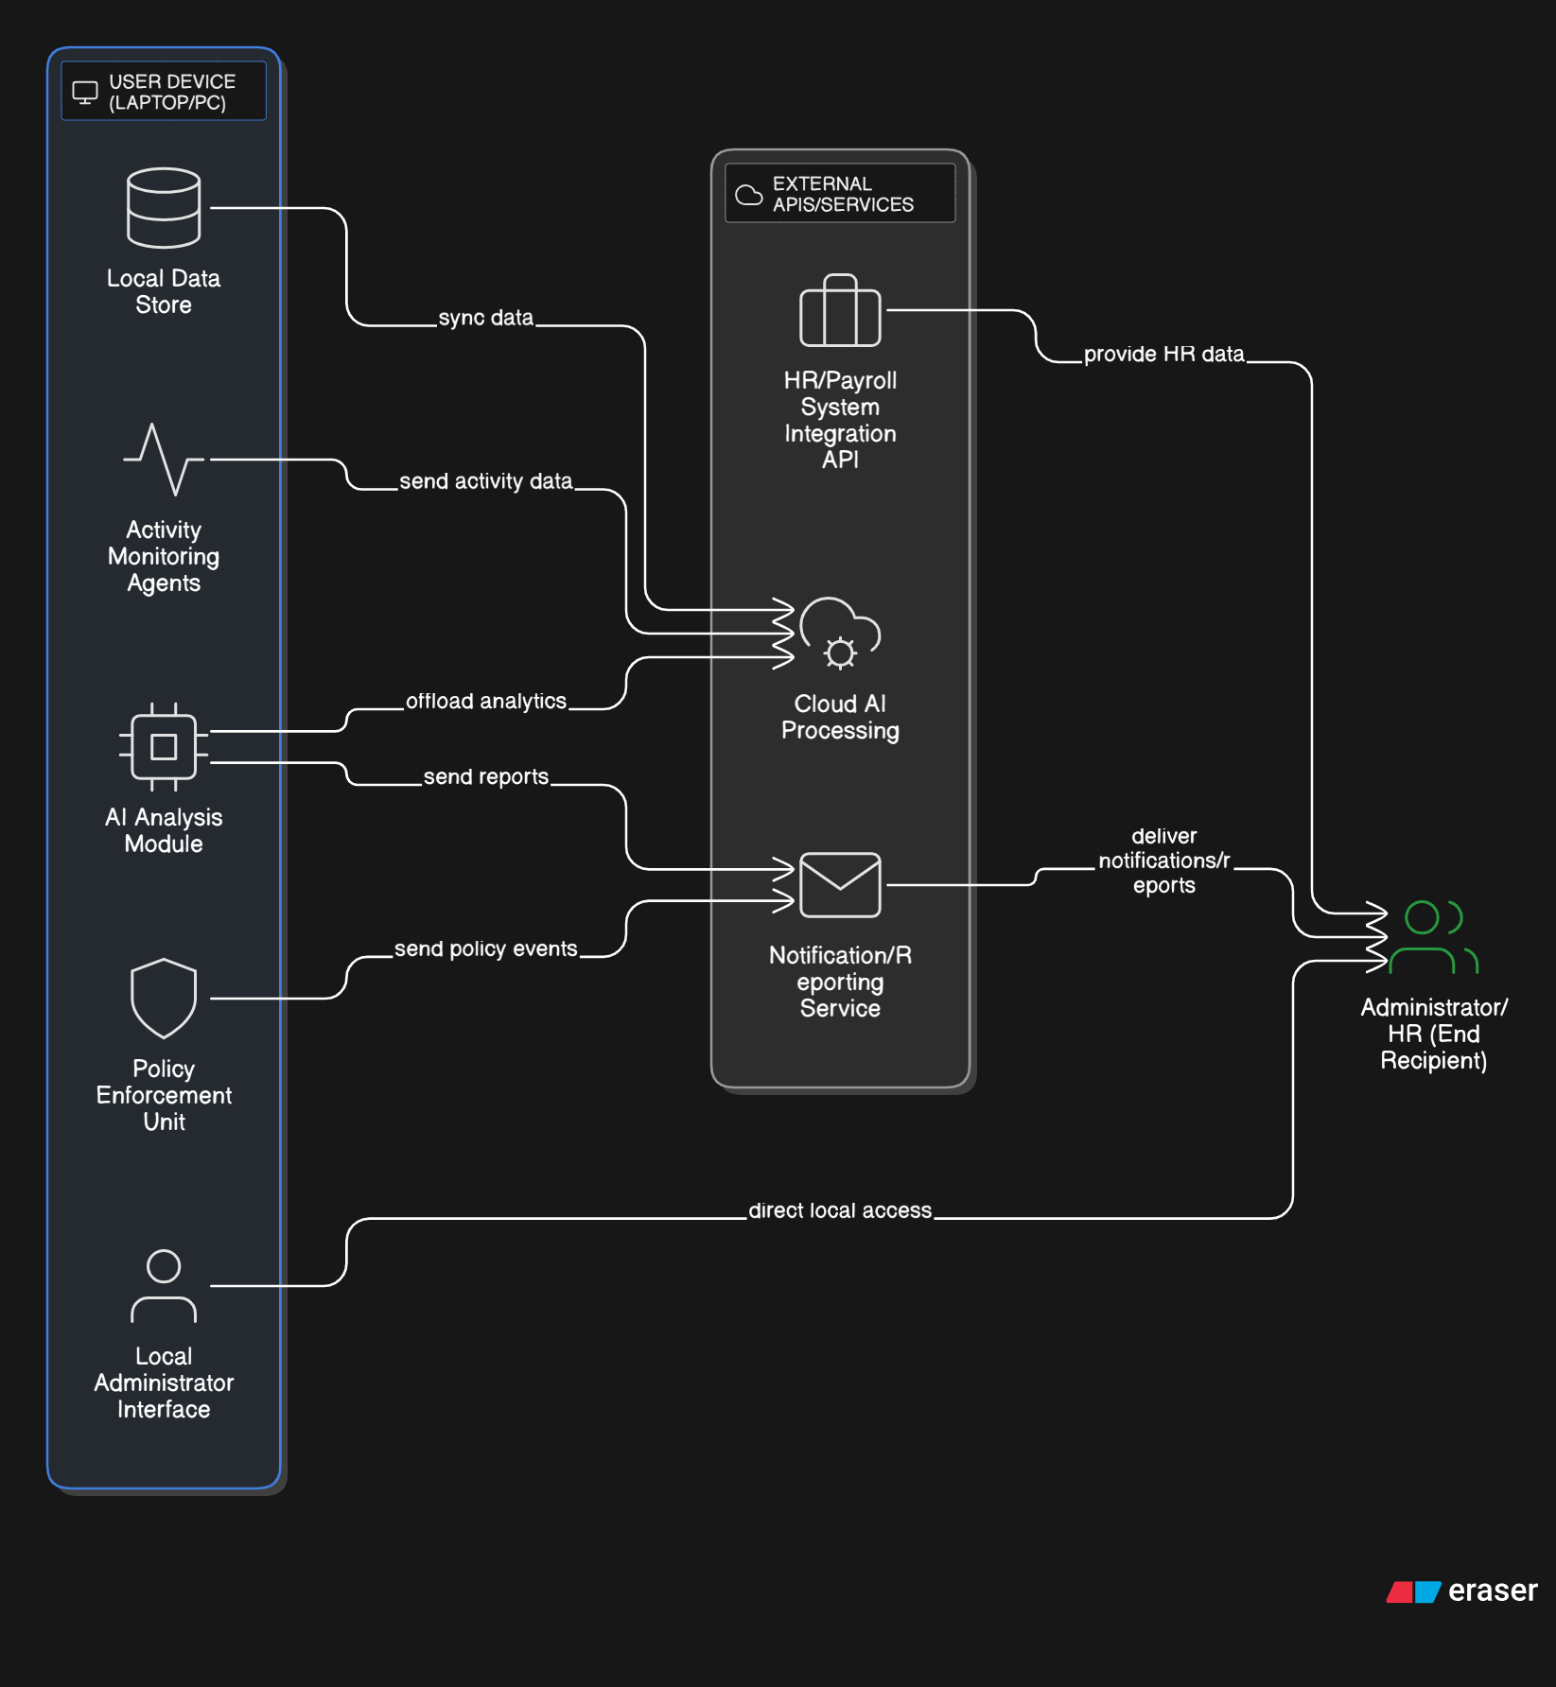

Figure 4.2: Deployment Diagram Showing External API Integration
Figure 4.2 illustrates the deployment structure of the AI-Based Tracker and Blocker System with emphasis on how internal components and external APIs are integrated into its operation. The system functions primarily through a User Device (Laptop/PC), which runs the core components including the Activity Monitoring Agents for capturing live digital inputs, the Local Data Store for secure storage, the AI Analysis Module for real-time processing, and the Policy Enforcement Unit for blocking. This device interfaces with several External APIs/Services to carry out its comprehensive monitoring and reporting functionality. These can include Cloud AI Processing for computationally intensive analytics, a Notification/Reporting Service for dispatching performance reports or alerts, and potentially an HR/Payroll System Integration API. Upon detecting activity or deviations, the system communicates with these services to promptly notify Administrators or HR personnel, ensuring efficient workforce management.

Protocol Architecture
The protocol stack includes four layers:
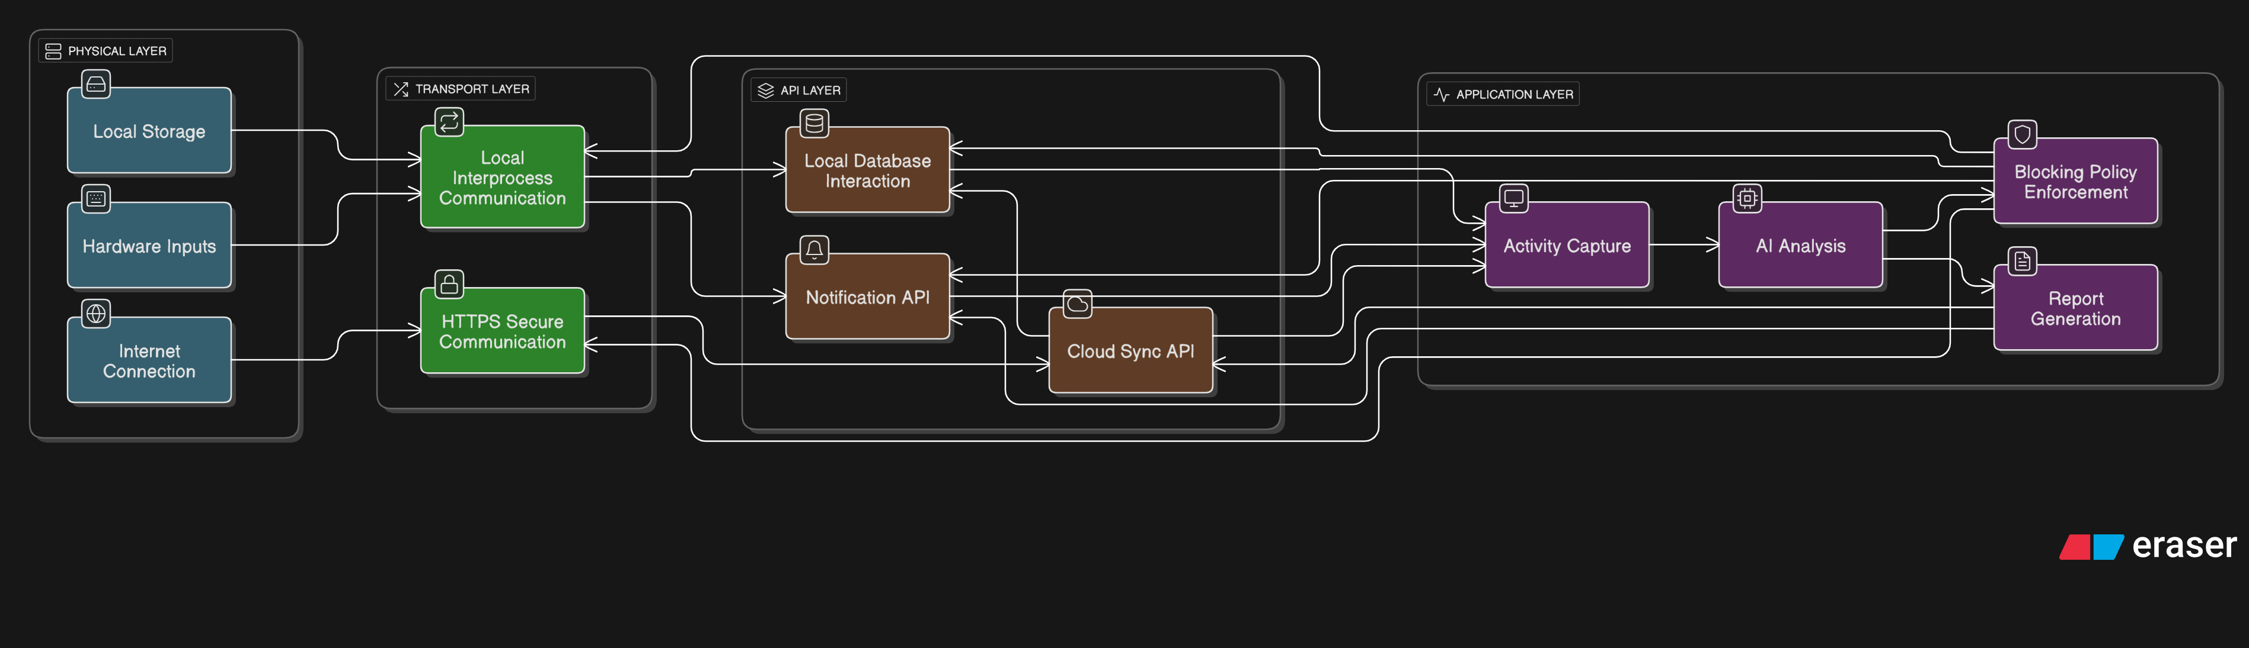

Figure 4.3: Protocol Architecture of the Data Transmission and Control
The Figure 4.3 illustrates the layered protocol architecture employed in the data transmission and control mechanism of the AI-Based Tracker and Blocker system. It is structured into four distinct layers:
- Application Layer: This topmost layer is responsible for initiating the activity monitoring process. It handles Activity Capture (keyboard, mouse, app/web, screen), performs AI Analysis for productivity and deviation detection, manages Report Generation, and executes Blocking Policy Enforcement.
- API Layer: This layer integrates various APIs that facilitate core functionalities. It includes Local Database Interaction for storing collected activity data, a Cloud Sync API for securely uploading data and reports to a central server, and a Notification API for sending alerts or reports to administrators.
- Transport Layer: This layer ensures the secure transmission of data using the HTTPS protocol for network communication, safeguarding communication between system components and external APIs. It also includes Local IPC for secure communication between different modules running on the same device.
- Physical Layer: At the base, this layer consists of the hardware components like Keyboard, Mouse, CPU, and Display for input and processing, the Internet Connection that supports network communication, and Local Storage (HDD/SSD) for persistent data retention.
Each layer plays a crucial role in enabling seamless and secure data collection, analysis, and control from digital activity detection to report delivery and blocking enforcement.

Flow Chart/Activity Diagram
Demonstrates the logical execution steps of the system from start up to response:
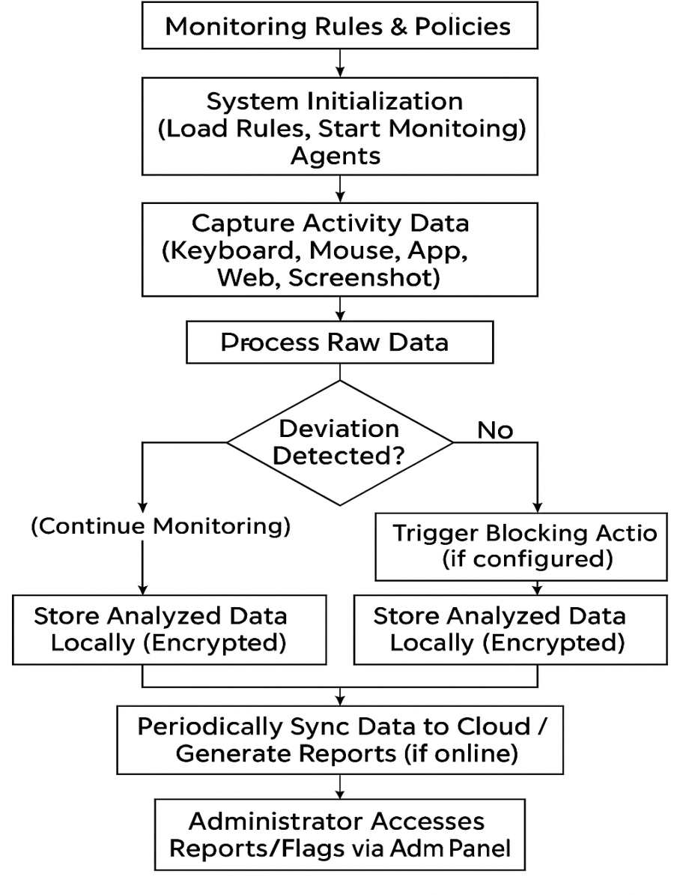

Figure 4.4: Flow Chart of System Operation
The Figure 4.4 Flow Chart of System Operation visually represents the logical sequence of the AI-Based Tracker and Blocker system. The operation begins when the Administrator Configures Monitoring Rules & Policies. The system then undergoes System Initialization, loading these rules and starting the Activity Monitoring Agents. It enters a Continuous Monitoring Loop, actively capturing various Activity Data such as keyboard inputs, mouse movements, application usage, website visits, and screenshots. This raw data is Processed, and the AI Analysis engine evaluates it to identify productive or non-productive activities. If a Deviation is Detected, the system can Trigger Blocking Actions (if configured) and Flag the Activity for Reporting. All analyzed data is Stored Locally (Encrypted) and Periodically Synced to Cloud / Reports are Generated when online. The process concludes when the Administrator Accesses Reports/Flags via the Admin Panel to take appropriate management decisions, or when the system is manually shut down. This logical flow ensures continuous data collection and timely insights for workforce optimization.

State Transition Diagram
Outlines the various operational states of the system:
- Idle/Monitoring: System is running silently in the background, continuously collecting raw activity data.
- Activity Detected: A significant event (e.g., app launch, website visit, period of inactivity) triggers deeper analysis.
- Analysing Productivity: AI engine is processing collected data against configured rules and patterns.
- Flagging/Blocking: System identifies a deviation and initiates reporting or an automated blocking action.
- Reporting/Logging: Data is compiled into reports, stored, and sent to administrators.
- Configuration Mode: (Transition from Idle for Admin setup).
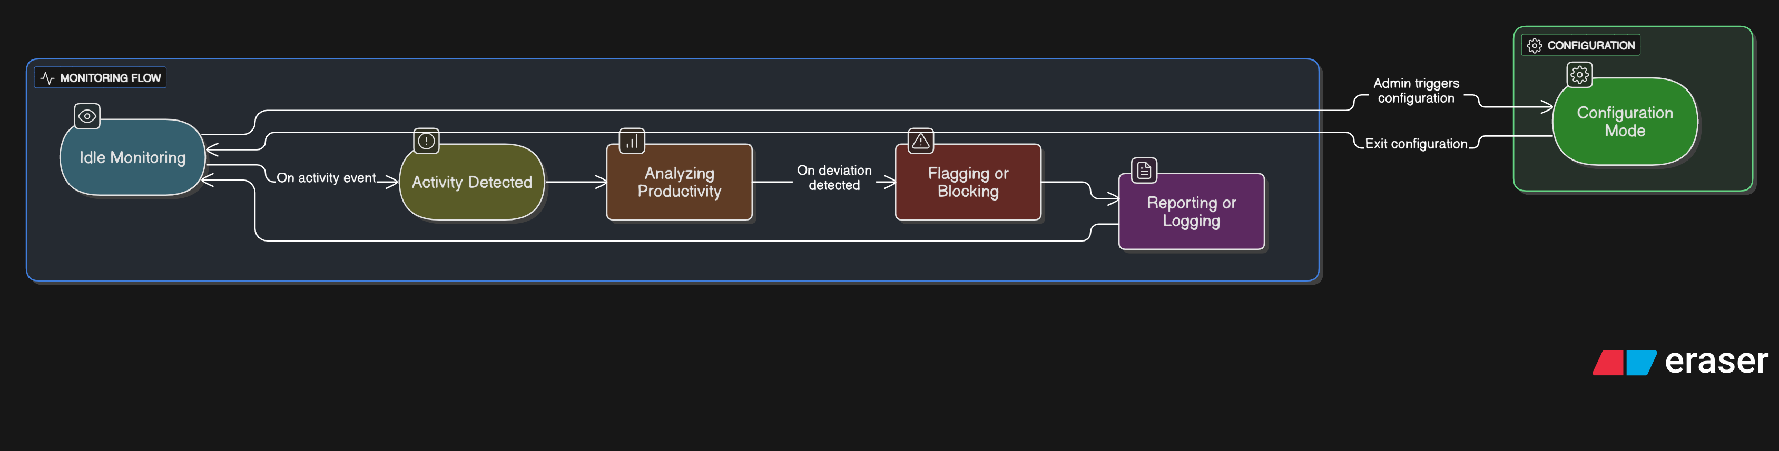

Figure 4.5: State Transition Diagram for Emergency Flow
The Figure 4.5 State Transition Diagram for Employee Monitoring Flow illustrates the key operational states of the AI-Based Tracker and Blocker system. As shown in the figure, the system primarily resides in the Idle/Monitoring state, continuously collecting raw employee activity data. Once a significant Activity is Detected, it transitions to the Analyzing Productivity state, where the AI engine processes the collected information against predefined rules. If a deviation or non-productive pattern is identified, the system moves to the Flagging/Blocking state, where it either flags the activity for reporting or initiates an automated blocking action. After these actions are completed, the system enters the Reporting/Logging state to finalize data compilation and storage, before returning to the Idle/Monitoring mode. An Administrator can transition the system to and from a Configuration Mode for system setup and rule management. This loop ensures that the system is always ready to respond to and provide insights into employee productivity.

Sequence Diagram
Describes step-by-step interactions:
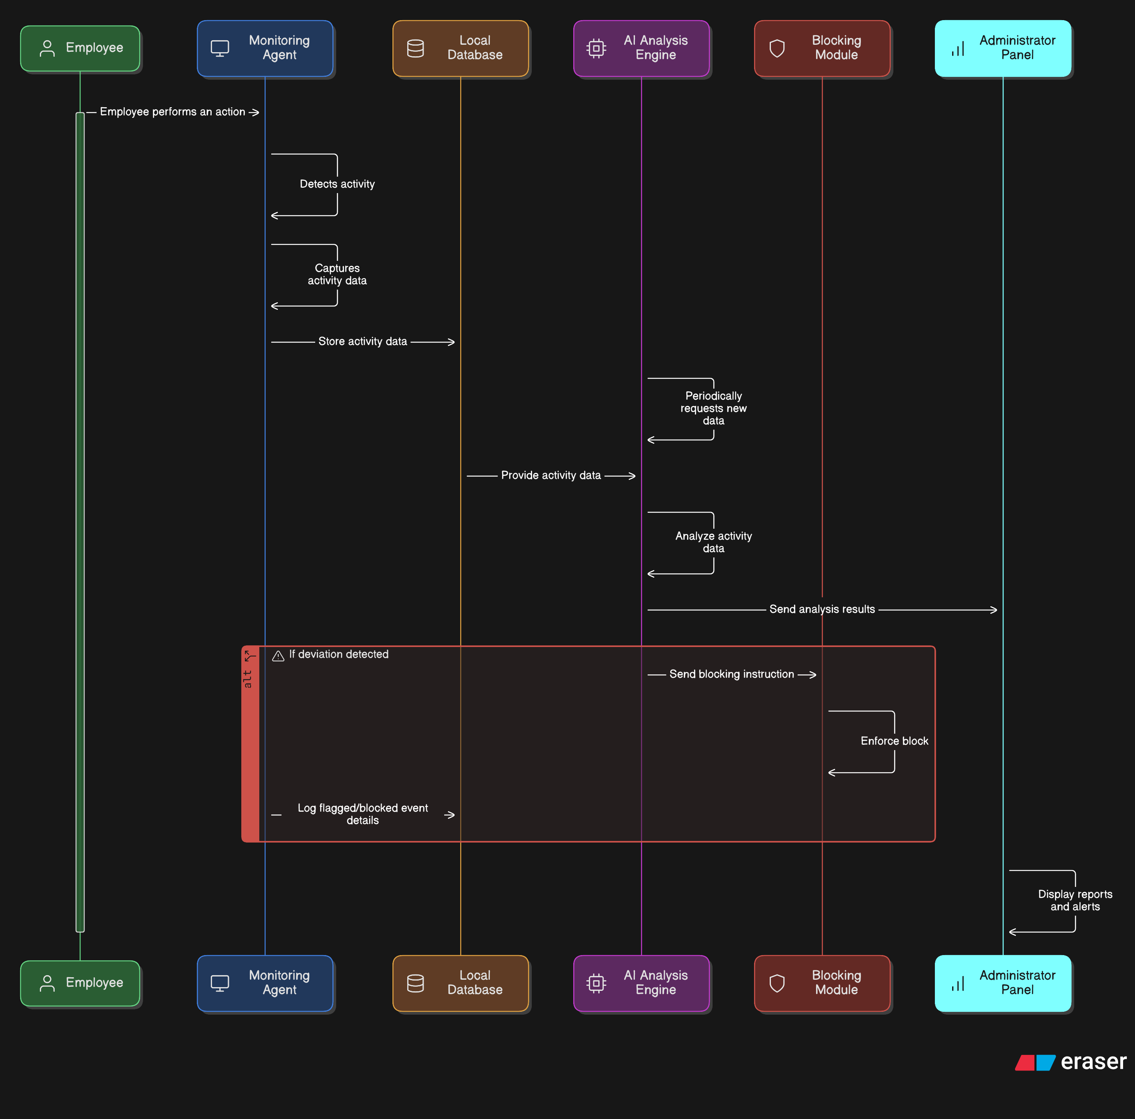

Figure 4.6: Sequence Diagram of Alert Execution
The Figure 4.6: Sequence Diagram of Activity Monitoring and Control Execution illustrates the step-by-step interaction between various system components during an employee's digital activity. As shown in the figure, the Employee performs an action (e.g., typing, opening an application, visiting a website), which is immediately detected by the Monitoring Agent. The Monitoring Agent then captures relevant data (such as keystrokes, application information, visited URLs, or screenshots) and stores this raw activity data in the Local Database. Periodically, the AI Analysis Engine requests new data from the Local Database, which then provides the activity data. The AI Analysis Engine analyses this data for productivity patterns and deviations. It then sends the analysis results to the Administrator Panel for reporting. If a deviation is detected, the AI Analysis Engine also sends a blocking instruction to the Blocking Module, which then enforces the block (e.g., by closing an application or redirecting a URL). Concurrently, the Monitoring Agent logs the event (e.g., activity flagged or blocked) in the Local Database for future reference and comprehensive reporting. The Administrator Panel displays these reports and alerts, providing continuous oversight.
4.7 Data Flow Diagram
Details how data is processed from input to output:
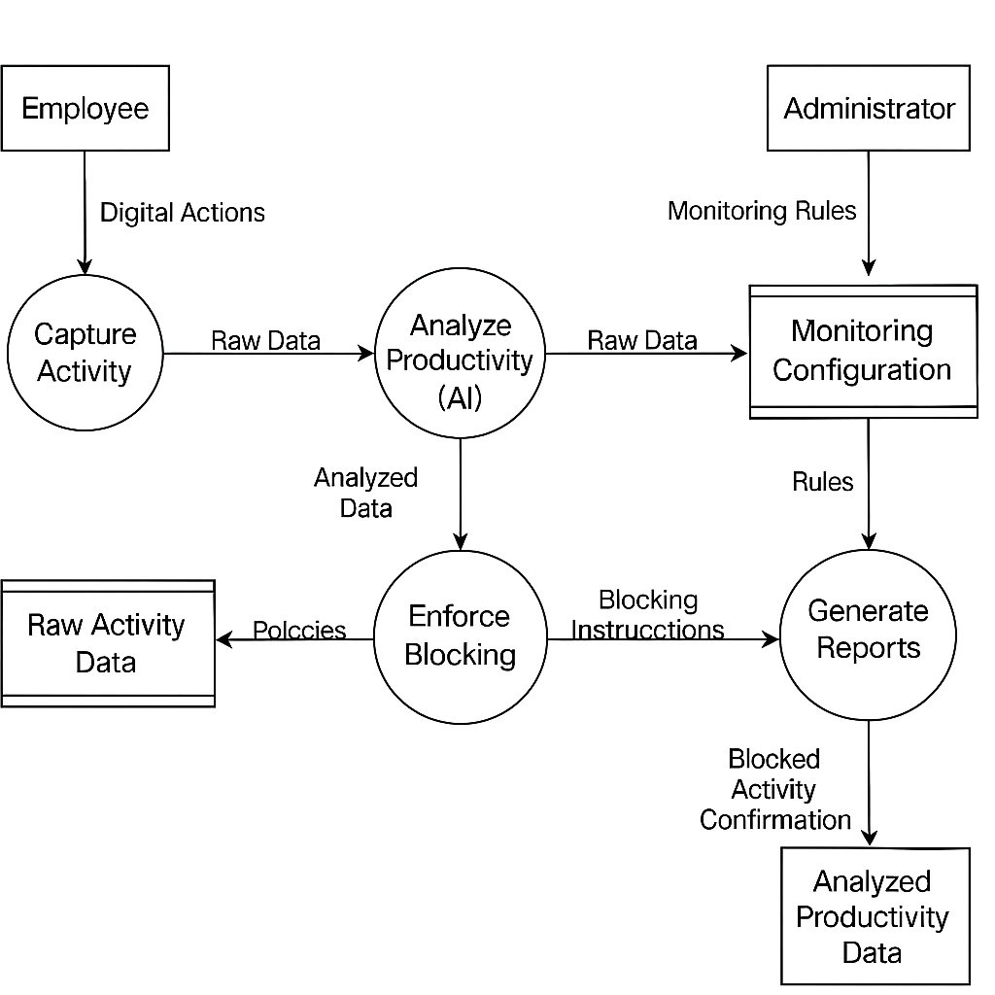

Figure 4.7: Data Flow Diagram from Employee Activity to Productivity Report

The Figure 4.7: Data Flow Diagram from Employee Activity to Productivity Report illustrates the core workflow of the AI-Based Tracker and Blocker system. As shown in the figure, the process begins with Employee Activity as the primary input. This activity is first processed by the Capture Activity component, which collects raw data and stores it in Raw Activity Data storage. The Analyze Productivity (AI) process then retrieves this raw data, along with Monitoring Configuration provided by the Administrator, to perform intelligent analysis. The results of this analysis are stored as Analyzed Productivity Data. This analyzed data flows to the Generate Reports process, which compiles comprehensive reports for the Administrator. Simultaneously, based on the Analyzed Productivity Data and Monitoring Configuration, the Enforce Blocking process takes action to restrict unauthorized activities. This data flow ensures a seamless transition from employee activity to actionable insights and automated controls, enabling efficient workforce management.

CHAPTER 5
CONCLUSION
The development of the Secret Phrase Triggered Emergency Alert and Evidence Recording System successfully addresses the critical need for a reliable, covert, and automated safety solution for individuals exposed to life-threatening or vulnerable situations. Traditional emergency alert mechanisms often rely on manual activation, visible user interaction, or wearable accessories, which may not be feasible during physical restraint, surveillance, panic, or medical emergencies. This project overcomes such limitations by introducing a fully speech-activated and discreet emergency framework capable of responding rapidly without drawing attention to the user.
The proposed system integrates advanced artificial intelligence speech recognition, keyword spotting technology, automated multi-channel communication, and real-time geolocation tracking to provide an immediate response once the predefined secret phrase is detected. Through continuous background monitoring, the system ensures readiness without requiring any physical action from the user. The implementation of automated SMS alerts, voice call initiation, real-time location sharing using Google API, and audio evidence recording significantly enhances the chances of timely rescue and legal protection.
Testing and evaluation confirmed that the system performs efficiently under varying acoustic environments, including low volume speech, whispering, and noise-prone conditions. The accuracy of phrase detection and responsiveness of API-based communications demonstrated strong reliability and usability across real-world scenarios. The functionality of the system fulfills key objectives such as discreet activation, rapid notification, authenticated contact management, and secure event logging.
Overall, the system proves to be a scalable and impactful safety solution suitable for individuals facing domestic abuse, medical emergencies, kidnapping risks, or any situation where overt help-seeking is impossible. By combining speech-based artificial intelligence, automated safety workflows, and secure digital evidence handling, the project contributes meaningfully to modern emergency response technologies and personal safety innovation.
While the system meets its intended goals, there remains potential for enhancement. Future improvements may include multilingual speech recognition support, emotional tone analysis, wearable device integration, machine learning-based false trigger suppression, offline-first processing models, and automatic escalation to law enforcement networks. With these advancements, the system can evolve into a highly adaptive, intelligent, and widely adoptable safety platform.
In conclusion, this project demonstrates that technology can play a powerful role in protecting human life by enabling silent communication during crises. The successful implementation validates the feasibility, relevance, and societal importance of covert emergency alert systems powered by artificial intelligence and automated communication frameworks.

REFERENCES
[1] Cheng, P., & Roedig, U., “Personal Voice Assistant Security and Privacy—A Survey,” IEEE Communications Surveys & Tutorials, 2022.
[2] Kumari, N., Cho, M., Dixon, P., & Naik, D., “Flexible Keyword Spotting Based on Homogeneous Audio-Text Embedding,” International Conference on Acoustics, Speech and Signal Processing (ICASSP), 2024.
[3] Yang, G., Gu, Y., Macha, S., Tang, Q., & Liu, Y., “On-Device Constrained Self-Supervised Learning for Keyword Spotting,” International Conference on Acoustics, Speech and Signal Processing (ICASSP), 2024.
[4] Valentini-Botinhao, C., Blanco, A. L. A., Klejch, O., & Bell, P., “Efficient Intelligibility Evaluation Using Keyword Spotting,” ICASSP, 2023.
[5] Reddy, M. S., Vamsi, C., & Kathambari, P., “Rescue Me: AI Emergency Response and Disaster Management System,” International Conference on Advanced Intelligent Systems (ICAIS), 2024.
[6] Abu Zaid, M. I. M., Abdullah, R., Ismail, S. I., & Dzulkefli, N., “IoT-Based Emergency Alert System Integrated with Telegram Bot,” IEEE Symposium on Computer Applications & Industrial Electronics (ISCAIE), 2023.
[7] Weerasinghe, K., Janapati, S., Ge, X., Kim, S., Iyer, S., & Stankovic, J., “Real-Time Multimodal Cognitive Assistant for Emergency Medical Services,” IEEE International Conference on Pervasive Computing and Communications (PerCom), 2024.
[8] Devika, T. V., et al., “ResQlink: Smart Kidnap Detection and Emergency Alert System,” International Conference on Advanced Intelligent Systems (ICAIS), 2025.
[9] Patil, S. R., Srividya, B. S., Agarwal, L., & Raj, R., “Women Safety Alert System Using IoT with Fingerprint Authentication and Real-Time Alerts,” IEEE Conference on Electronics, Computing and Communication Technologies (CONECCT), 2024.

